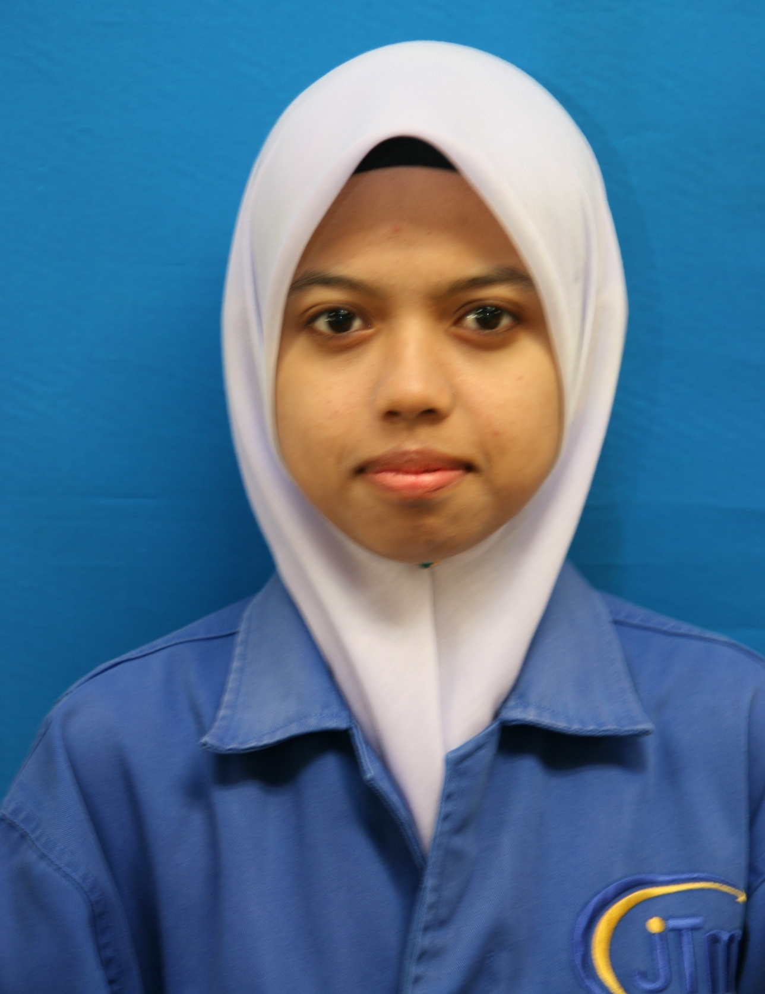
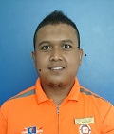

MOHD FAIZAL BIN MUSTAFAR
CONTACT INFORMATION

ADDRESS : NO 521 FELDA TENGGAROH 2 86810
MERSING JOHOR
CONTACT NO : 012-7987723
EMAIL : bobfrtl@gmail.com
PERSONAL PARTICULARS

DATE OF BIRTH : 12 FEBUARI 1987
IC NO : 870212-23-5661
GENDER : MALE
MARITAL STATUS : MARRIED
HEIGHT : 175 CM
WEIGHT : 95 KG
RELIGION : ISLAM
RACE : MALAY
NATIONALITY : MALAYSIA
HOBI : OUTDOOR ACTIVITIES,TRAVELLING AND READING
EXPECTED SALARY : RM 2,000.00 (NEGOTIABLE)
PERSONAL PARTICULARS

Year’s | EDUCATIONAL
2015 | BASIC SAFETY HEALTH AND ENVIRONMENT FOR OIL N GAS WITH OGSP  (IKBN PENAWAR,KBS,NIOSH,JPDC)
2014 | SIJIL KEMAHIRAN MALAYSIA (NATURE GUIDE)THP 2, 3  (IPPJ SDN BHD),MOTAC,PERHILITAN
2004 | SIJIL PELAJARAN MALAYSIA  (SEK.MEN.KEB TENGGAROH A)
2002 | PENILAIAN MENENGAH RENDAH  (SEK.MEN.KEB ANJUNG BATU)
1999 | UJIAN PENILAIAN SEKOLAH RENDAH  (SEK.REN.KEB.SERI PANTAI)

YEAR | KOKURIKULUM | JAWATAN | PERINGKAT
2007-PRESENT | PJPK SMSSI | FASILITATOR | INTERNATIONAL
2014 | PEMANDU PELANCONG ALAM SEMULAJADI(JOHOR) | AHLI | STATE
2000-2004 | PENGAKAP | AHLI BIASA | SCHOOL

CO-CURICULUM ACTIVITIES
WORK EXPERIENCE
RENAISSANCE HOTEL ,PERMAS JAYA (AUGUST 2016 – PRESENT)
RECEIVING ASSISTANT
- To ensure all goods delivered in good quality and quantity according to Purchase Order
- To inspect, accept or reject inbound materials

FELDA RESIDENCE TANJUNG LEMAN, MERSING
RECREATION SUPERVISOR (2014- JULY 2016)
- To ensure recreation facilities are maintained in order to ensure a safe, clean and appropriate environment for recreation activities
- Assist with planning and developing sport and recreation programs in order to ensure that activities are made available for all community members
- Implement recreation programs to ensure that residents have access to sports, recreation and leisure activities
- Assist receiving department

RECREATION ASSISTANT (2010-2014)
- Conduct outdoor and indoor activities
SEKOLAH MENENGAH SAINS SULTAN ISKANDAR, MERSING
ASSISTANT SCHOOL CORPARATION (2007-2010)
- To assist daily sales
- To control and monitor stock
- To make sure goods in good condition
SUMMARY OF STRENGTH
I am a hardworking and self-motivated person. I can work under pressure with minimum supervision and can corporate well in a team. I am willing to gain and learn new skills and experience to increase expertise and competencies.
REFERENCES
PN. AZLINITA BINTI TUMIN EN.MOHD EZUDDIN BIN JAINI
EXEC FRONT OFFICE LECTURER, MATRIKULASI MELAKA
FELDA RSIDENCE KUALA TERENGGANU. PHONE NO : 0127110404
PHONE NO : 0177247092

